**Rules:**

Each player has a full, or half (separate the black and red numbers) deck of cards, this is your draw pile.

To start, put all your marbles in the start (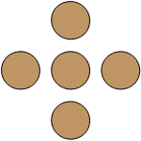) in front of you. Draw 6 cards from the top of your draw pile. Move your marble and discard the card you played into your own discard pile.

The object of the game is to move all marbles clockwise (↻) around the board and into Home (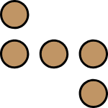).

Every other player around the board is a partner. When you get all your marbles in Home, you start helping your partner to your left.

You may not pass your own marble going forward (↻) or backwards (↺), but you can pass any other marble. You must have the exact number to move your last marble into Home.

You must play if you can (even an 8, 9, or a Joker). If you cannot play, you discard and pass.

If you already have a marble in front of Home (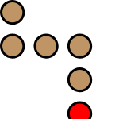) and someone sends another marble there, one of the marbles goes back to start.

When your draw pile is gone, reshuffle the deck and start over again.

*Ace's can move a marble out of start or advance 1 space.

*2,3,4,5,6, and 10 advance the number on the card. *7 advances 7 or can be split between 2 of your marbles in play. If you need less than 7 to move your last marble into home, you can use the remainder of the 7 on your partner's marble to your left (you will now move his marble when it is your turn again).

*8 can only move backward (↺) 8 spaces.

*9 moves 9 spaces or can split between 2 marbles and move 1 or both forward (↻), or backwards (↺). *kings, Queens, and Jacks can move a marble from start (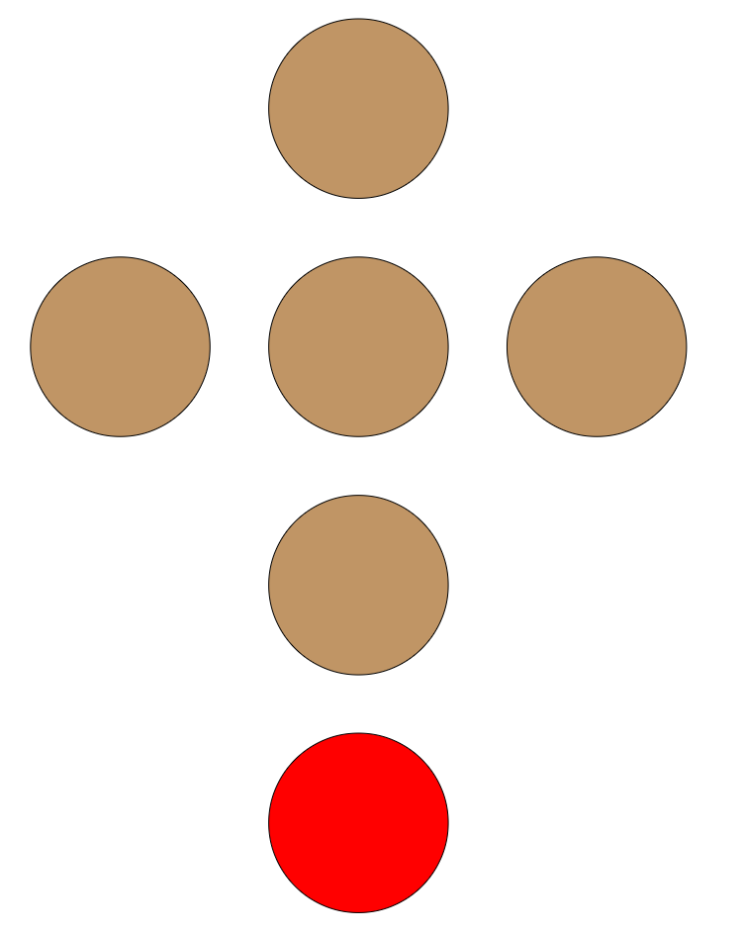) or advance 10 spaces.

*Jokers can trade one of your marbles (even if it is in start) with any marble. If with a partner's marble, his marble goes to the space in front of his Home, if with an opponent's marble, their marble goes back to start.

The first team to get all their marbles home WINS!

**Other popular suggested rules:**

Ace rule: Using an ACE, come out from the start, move one space forward, or move 11 spaces forward.

2 rule: Using a 2 card, switch any one of your marbles in play with any other marbles in play on the board, just trade places.